 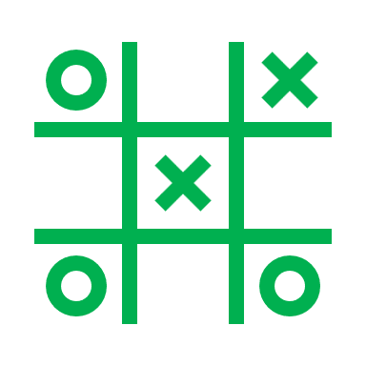 

Game Design Document

for a VR Escape Room

The Elemental crystal Conservatory

**Trina**

**Confidential Disclaimer**

This Game Design Document has been prepared for review by (Name). All information is confidential and proprietary and should not be shared without written permission.

**Overview of the Game**

**TITLE**

**The Elemental Crystal Conservatory**

**GENRE: Puzzles/Tasks**

**INSPIRATIONAL REFERENCES: The Room series, Fire boy & Water girl**

**I have drawn inspiration from this puzzle game called The Room Series and design and ideas from the game called Fire boy & water girl elements.**

**BASIC NARRATIVE**

**Players find themselves trapped within a mystical conservatory where the balance among four elemental crystals (Earth, Water, Crystal, and Fire) has been disrupted. This imbalance has locked the conservatory's doors, and to escape, players must restore harmony to each element by solving puzzles that align with their respective characteristics.**

**CONCEPT ART**

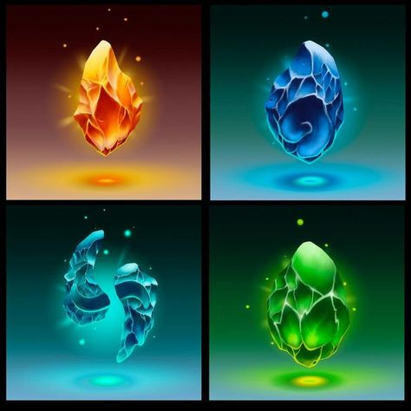

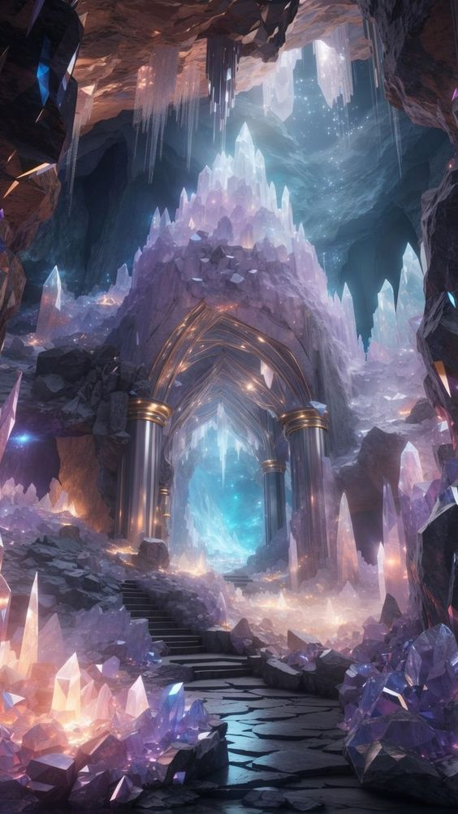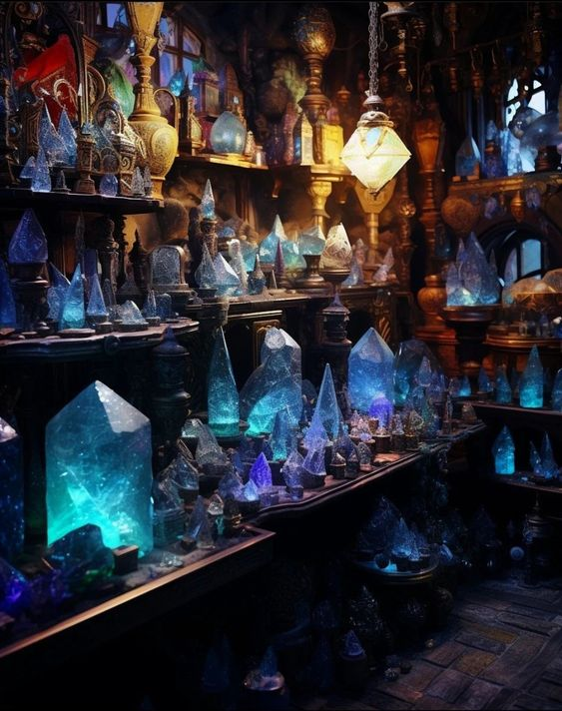

**UNIQUE SELLING POINTS**

**"The Elemental Crystal Conservatory" offers a captivating VR escape room experience where players explore four elemental realms Earth, Water, Crystal, and Fire within a mystical conservatory. Each realm features puzzles directly tied to its element, utilizing VR for realistic interactions with stones, water taps, wind chimes, and candles. Players uncover secrets, solve puzzles in multiple ways, and enjoy a cohesive narrative set in detailed, thematic environments, making "The Elemental Crystal Conservatory" deliver a uniquely engaging adventure that seamlessly blends interactive VR mechanics with compelling storytelling.**

**GAME LOOP**

**Enter and Explore (Initial Stage):**

* **Players spawn in the starting area of the conservatory, surrounded by the four elemental areas (Earth, Water, Crystal, Fire). The player is free to explore each area, collecting clues and items.**
* **The elemental crystals are in a state of disharmony, and the doors to each area are locked.**

**Solve Puzzles (Challenge Stage):**

* **Players interact with each elemental area, solving a puzzle to restore balance to the corresponding crystal.**
* **Clues and hints are provided throughout the area to aid the player.**
* **The puzzle solutions are unique to each elemental area.**

**Progress and Repeat (Reward Stage):**

* **After solving each puzzle, the player progresses to the next elemental area.**
* **The game loop repeats until all four puzzles are solved.**
* **With each puzzle solved, the player is rewarded with:**

**Audio of the doors opening to show that the puzzle was completed.**

**Access to the next elemental area.**

**A sense of accomplishment and progress.**

**Crystal Puzzle:**

**- Objective: Arrange colored crystals to the correct stone platforms on the ground**

**- Clues: colored crystals beside each stone platform**

**- Interaction: Drag and drop crystals into the correct stone platform and the next puzzle stage will be unlocked.**

**Water Crystal Puzzle:**

**- Objective: Find a clue to which button to click first on the stone bridge where under is water, then the bridge will appear. Find the correct key to then unlock the next puzzle stage.**

**- Clues: crystal buttons order, then find the key.**

**- Interaction: press buttons in the correct order and use the key to unlock the door.**

**Earth Crystal Puzzle:**

**- Objective: Break wooden crates and collect the stones items, place them on the stone table and the pickaxe will appear. Use the pickaxe to unlock the door and continue to the next puzzle.**

**- Clues: Read environmental clues to figure out the steps.**

**- Interactions: Use the axe to break crate, place stones on the stone table, use the pickaxe to unlock the door and proceed.**

**Fire Crystal Puzzle:**

**- Objective: Light candles in a height sequence**

**- Clues: different sized candles, find a scroll which gives a clue**

**- Interaction: light candles in ascending height order and door will be unlocked.**

**Locomotion Style: Teleportation Area**

* **Teleportation Mechanics: Players click on a floor to instantly transport to the corresponding marking in the next elemental room**

**Teleportation Details:**

* **Teleportation Areas: Players can teleport anywhere within designated teleportation areas in each elemental room.**
* **Activation: Players click on any point within the teleportation area to move instantly to that location.**
* **Flexibility: This allows for greater freedom of movement and exploration within the rooms, without being restricted to specific points.**

**FLOWCHARTS**

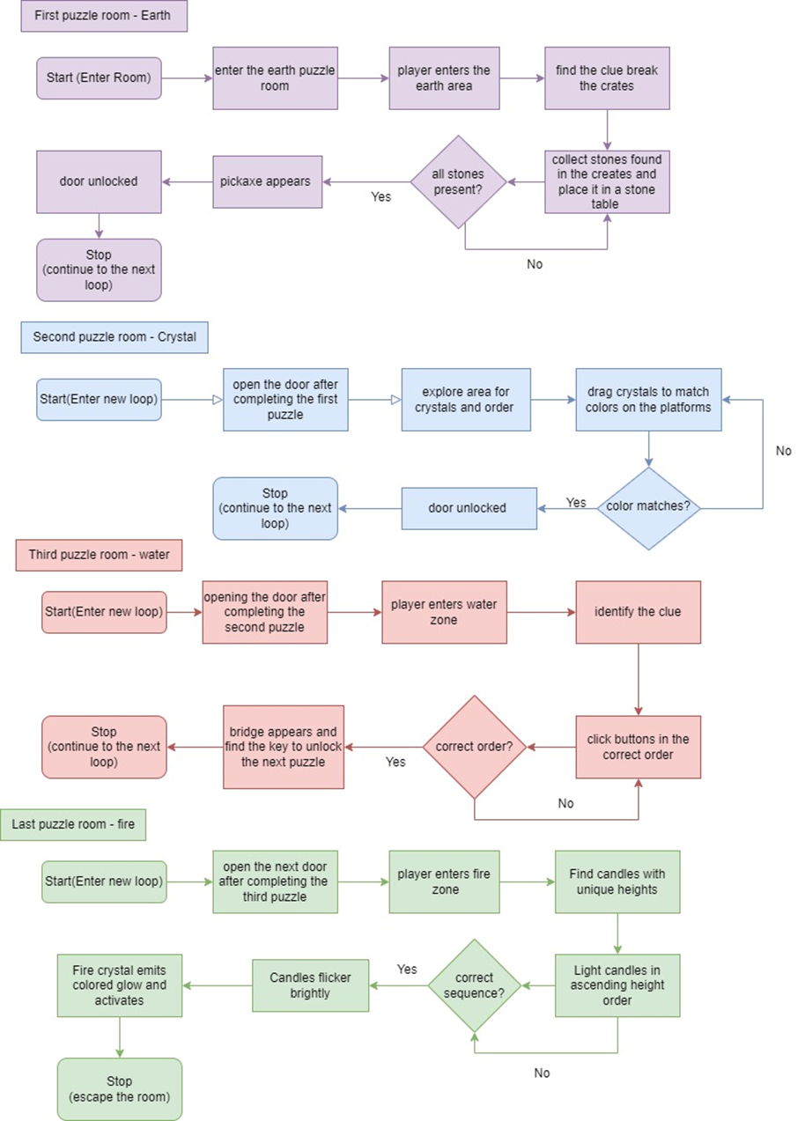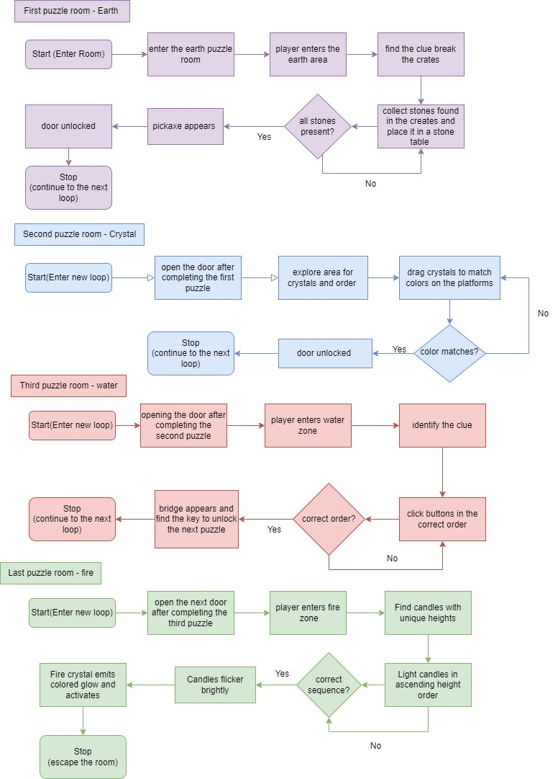

**STORYBOARD**

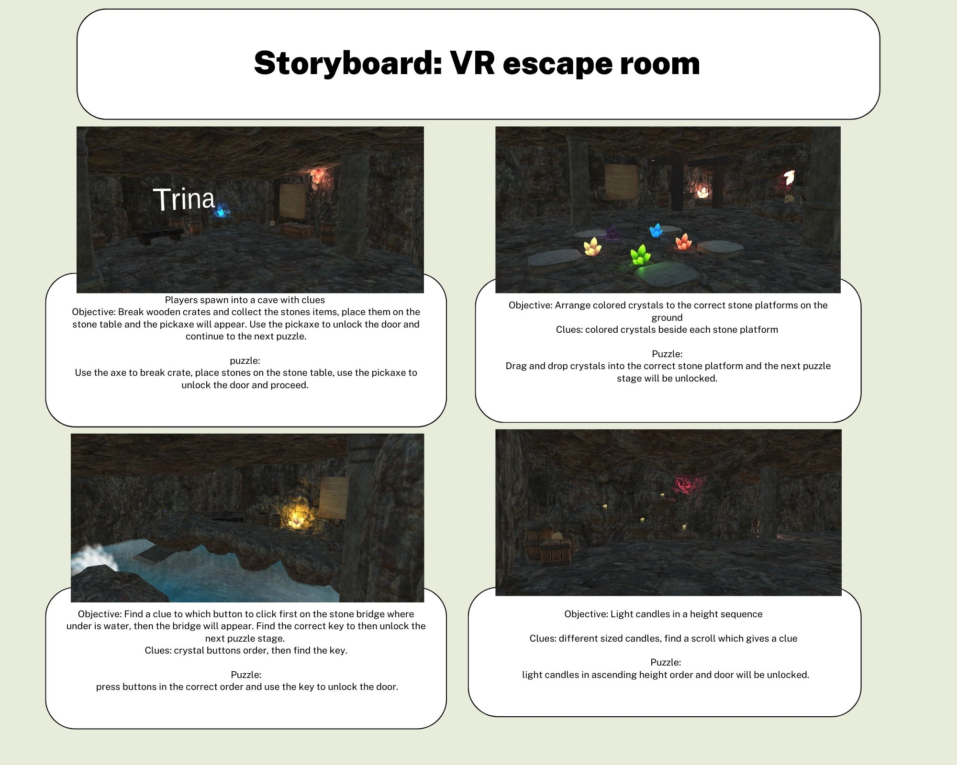

**GAMEPLAY SCOPE**

**Game Length: The game is designed to be a immersive, VR experience with a playtime of approximately 40-60 mins.**

**Levels: The game consists of 4 main levels, each representing a unique elemental room (Earth, Water, Air, Fire).**

**Average Playtime: Players can expect to spend around 10-15 minutes in each level, depending on their puzzle-solving skills and exploration pace.**

**Objectives:**

**Restore balance to the four elemental crystals**

**Solve puzzles to unlock new areas and progress through the game**

**Explore the conservatory to uncover hidden secrets and clues**

**Playable Characters:**

**There is one playable character, a mystical guardian tasked with restoring balance to the elemental crystals.**

**ART STYLE**

**The Elemental Crystal Conservatory features a vibrant, fantastical art style inspired by the mystical worlds of "Water Girl" and "Fire Boy", with a hint of the eerie and mysterious atmosphere from the "Rooms" series.**

**Environment**

**Dreamlike landscapes with elemental themes (water, fire, earth, crystal)**

**Vibrant coloured crystals and soft lighting, with a touch of eerie glow**

**Intricate details and textures, with a mix of organic and mystical elements**

**UI**

**Minimalist, intuitive design**

**Soft glow effects and animations, with a hint of magic and wonder**

**Inspirational Concepts**

**The eerie and mysterious atmosphere from the "Rooms" series**

**Underground illustrations and concept art with a mix of elemental and cave like themes**

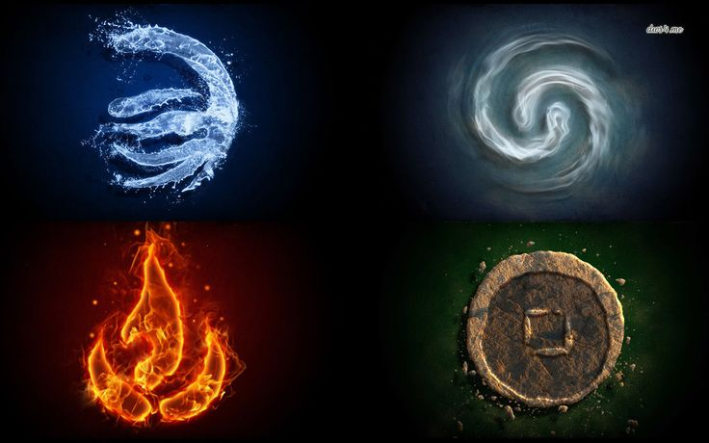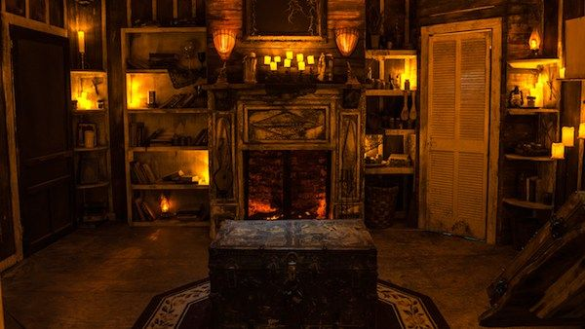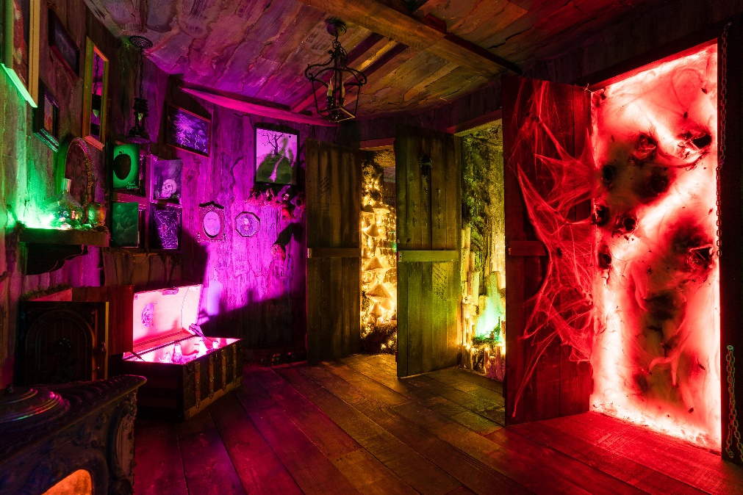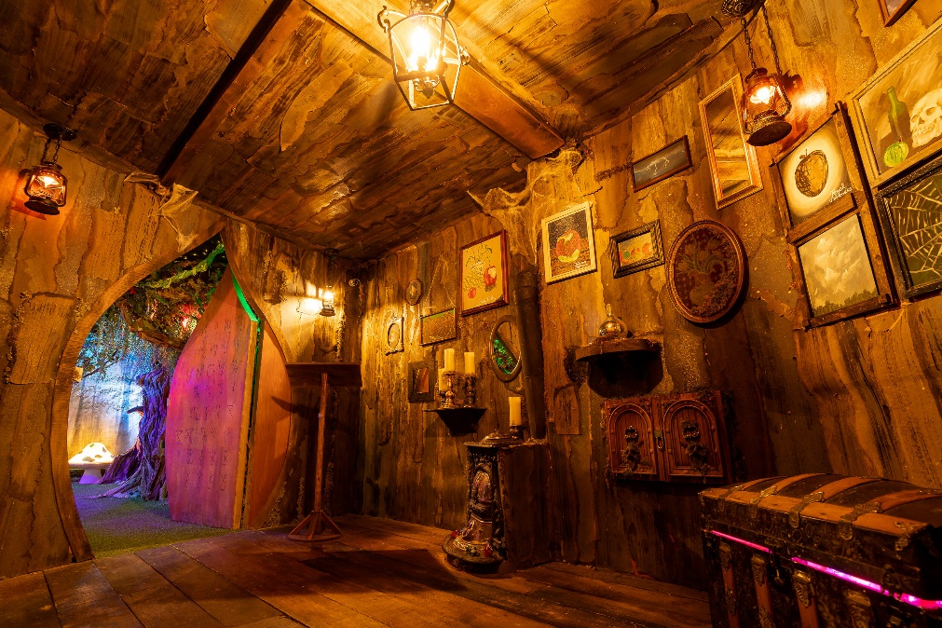

**PLAYER PROFILES STORIES**

**The game loop consists of entering a new level, exploring the environment, collecting elemental orbs and hidden items, solving puzzles to unlock new areas, engaging with characters and storylines, and completing challenges and achievements.**

**For the Narrative Enthusiast, the focus is on exploring the environment, solving puzzles, and engaging with characters and storylines to uncover the narrative and understand the lore and backstory. This player prioritizes immersing themselves in the game's world and story, taking the time to discover new areas and secrets. The gameplay experience is immersive and engaging, with a focus on storytelling and discovery.**

**For the Completionist, the priority is on collecting all elemental orbs and hidden items, completing challenges and achievements, and methodically exploring each level to achieve 100% completion. This player is driven by the desire to complete every aspect of the game and values the sense of accomplishment that comes with it. The gameplay experience is challenging and rewarding, with a focus on collecting and completing tasks.**

**MILESTONE SCHEDULE (GANTT CHART)**

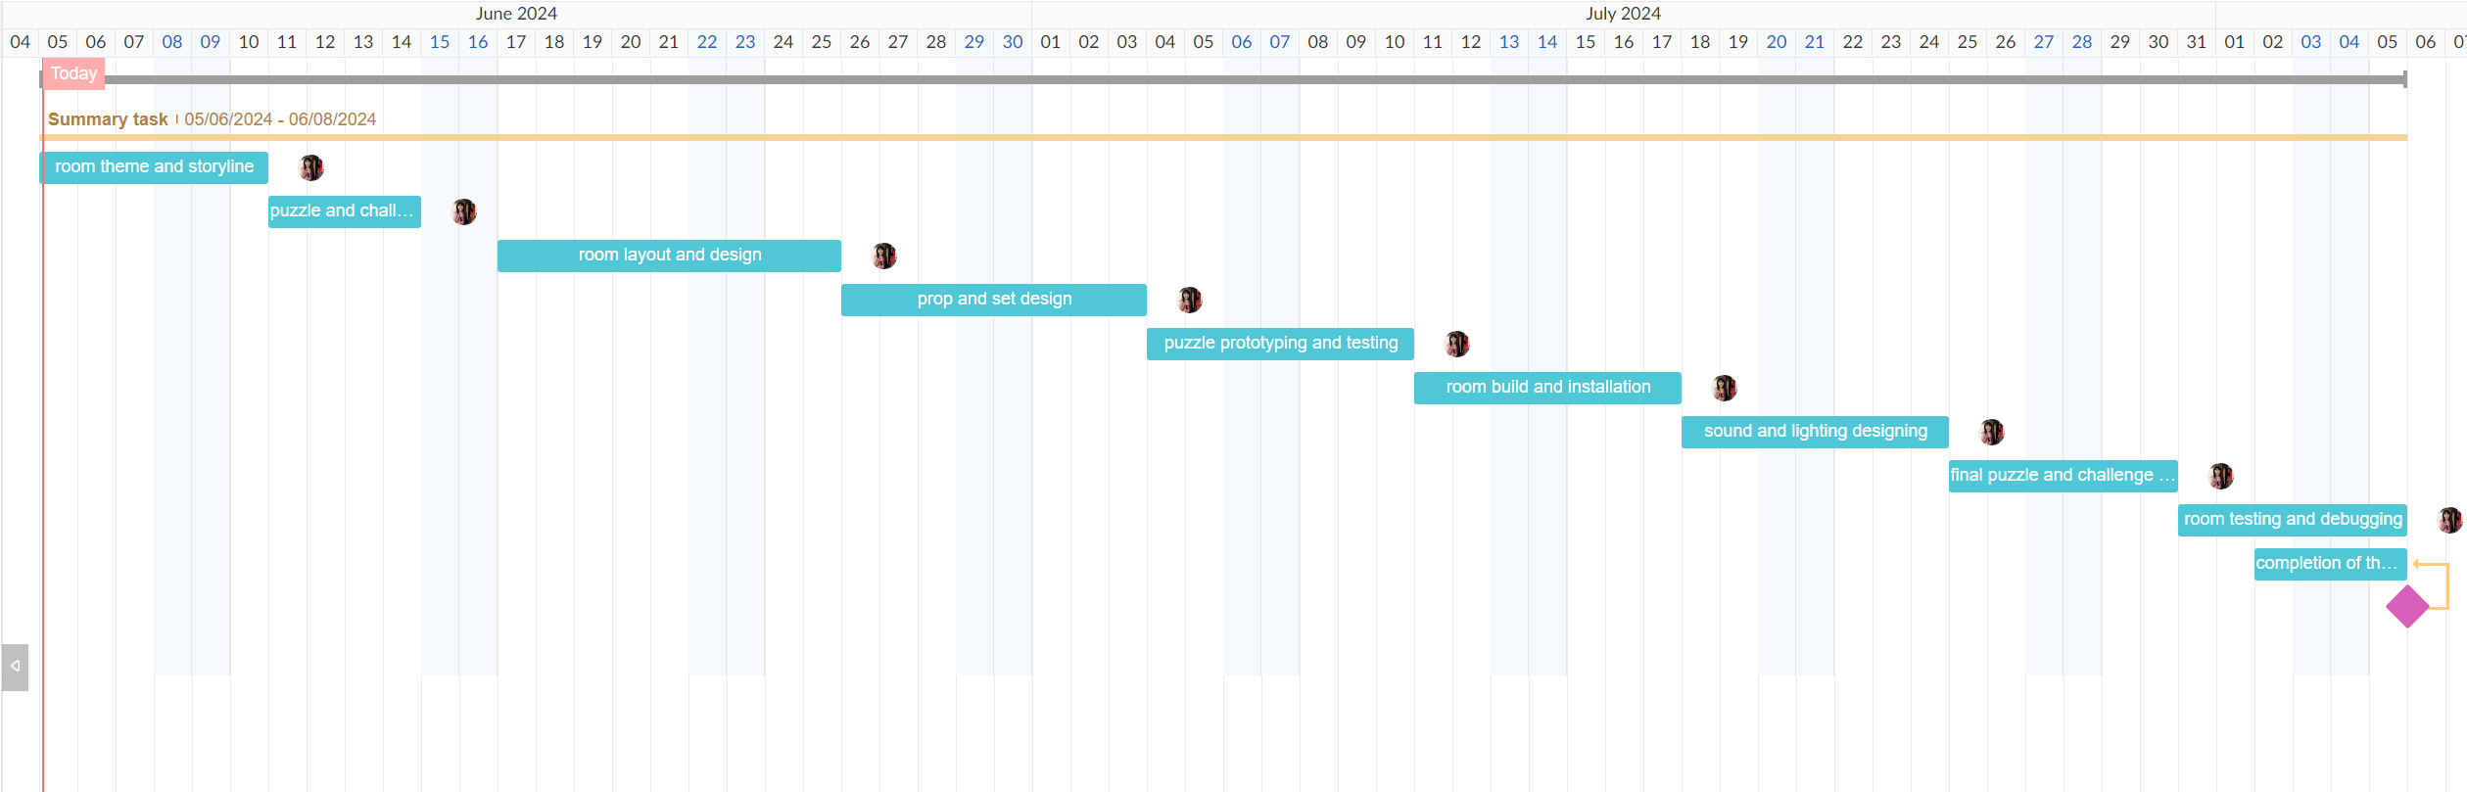

**Milestones:**

**Week 1: Room Theme and Storyline**

* **Define the theme and storyline of the game**
* **Develop the concept of the conservatory and the elemental crystals**

**Week 2: Puzzle and Challenge Design**

* **Design puzzles and challenges for each elemental theme**
* **Develop clues and hints to guide players**

**Week 3: Room Layout and Design**

* **Design the layout of the conservatory**
* **Create a detailed design of the room, including props and set dressing**

**Week 4: Prop and Set Design**

* **Design and create props and set dressing for the room**
* **Develop a detailed plan for building and installing the room**

**Week 5: Puzzle Prototyping and Testing**

* **Build prototypes of puzzles and challenges**
* **Test and refine puzzles and challenges**

**Week 6: Room Build and Installation**

* **Build and install the room**
* **Set up puzzles and challenges**

**Week 7: Sound and Lighting Design**

* **Design and implement sound and lighting effects**
* **Create an immersive atmosphere**

**Week 8: Final Puzzle and Challenge Tuning**

* **Refine and finalize puzzles and challenges**
* **Make any necessary adjustments**

**Week 9: Room Testing and Debugging**

* **Test the room for bugs and errors**
* **Make any necessary fixes**

**Week 10: Complete VR escape room**

* **Present final VR escape room**